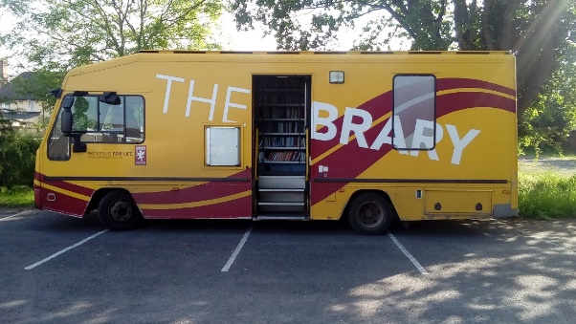
Friends of Milborne Port Library (FOMPL) JULY 2019
During the last month, the Library friends have had their final meeting with both County and Parish Councils about the transfer of the Library to the mobile library in the East Street car park in the second half of July. The Friends are now qualified as a Charity Incorporated Organisation. From now on the Friends of Milborne Port Library (FOMPL) will be referred to as ‘F19’
The Friends of Milborne Port Library hosted a very successful table at the Milborne Port Fete on June 1st. Members of the public were interested in the displays showing various events at the Library over the years and it was a great opportunity to talk face to face with people about the future of our library. In addition we took about £40 in donations.
You may remember we invited readers to come up with an inspiring name for the temporary library. At the fete visitors had the opportunity to tick their favoured selection and the result was THE JOLLY BOOK BUS, a name put forward by Pauline Cabell. Many thanks Pauline.
All being well the Jolly Book Bus will take up residence in the East Street car park in mid-August. For those wondering where this is, it is the street opposite the fish and chip shop with the London Road Clinic on your right and Café Pineapple on your left. Unfortunately there will be no room for computers for public use. However, once the Community Hub is built, housing the Library, computers and the iPad will once again be available for Library users.
Due to a fall in demand the Library will no longer stock Talking Book cassettes but are very happy to have been able to donate these to a worthy cause, The Brain Injury Trust. Talking Books on CD will be available once the Library is in its permanent home.
This year’s Summer Reading Challenge, Space Chase, starts on 13 July. However there is likely to be a delay in activities in the Library until the Jolly Book Bus is established. Anyone interested in taking part is encouraged to check out this website https://summerreadingchallenge.org.uk/. There is masses of information and encouragement to get your children reading during the summer holidays. The date of the annual event at the end of the challenge will be announced in the next Village Magazine.
Jill Spring jspring51@gmail.com

