Friends of Milborne Port Library (F19) – OCTOBER 2019

Friends of Milborne Port Library (FOMPL)
The annual Summer Reading Challenge party was a great success as usual. Even though the village was temporarily without a functioning Library service, Sue and Edwina ran a pop-up Library in the Village Hall through August. This meant that children were able to tackle the Summer Reading Challenge and we welcomed 23 children to the ‘Space Race’ party on Saturday 14 September. We owe enormous thanks to Roz Barrett and her helpers, without whom it would never have happened.
The Friends of Milborne Port Library (F19) have now signed a contract with Somerset County Council making an official Partnership. F19 Trustees held a meeting on 13th September. Among issues raised was the question of fund raising, now that we have taken on the responsibility of maintaining the Bus. One idea being considered is to approach local businesses and we will be working on this. So now that the Jolly Book Bus is fully functioning as a Library the focus is on sorting out any teething problems. This includes safe access for staff and library users. Meanwhile, if you have any difficulty getting into the Jolly Book Bus, please let the staff know. This will help us as we plan for access in the future.
The Jolly Book Bus has lots of new titles so come along and see what is on offer! Opening hours are as follows
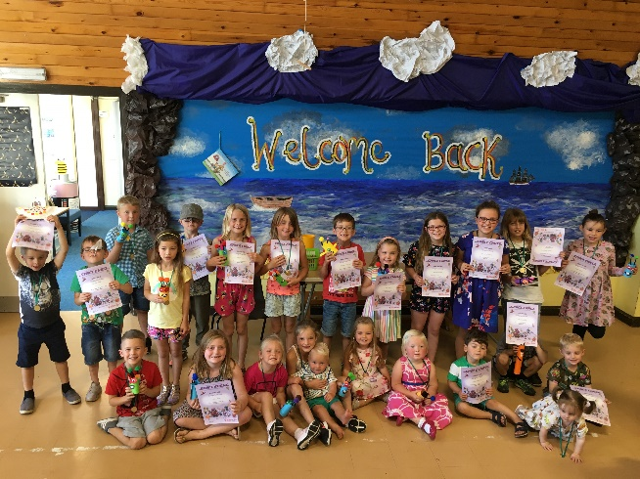
Tuesdays 9 am – 1 pm, 2.00 – 4.30
Fridays 9 am – 1 pm
Saturdays 9 am – 1 pm

Jill Spring
jspring51@gmail.com

